Marketing Campaign Analysis Report

Introduction
Marketing mix is a cornerstone of strategy, built around the four Ps: Product, Price, Place, and Promotion. This project focuses on analysing customer acquisition through exploratory data analysis (EDA) and hypothesis testing, using demographic, behavioural, and transactional data.

Data Preparation

Data Import & Cleaning: Verified variable age, Income. Missing income values were imputed using the average income grouped by education and marital status. There was Outlier present too in both age and income, and removed from the data frame
- Derived Variables:
  - Customer_Age = Current year – Year_Birth
  - Total_Children = Kidhome + Teenhome
  - Total_Spending = Sum of MntWines, MntFruits, MntMeatProducts, MntFishProducts, MntSweetProducts, MntGoldProds
  - Total_Purchases = NumWebPurchases + NumCatalogPurchases + NumStorePurchases
  - Total_AcceptedCmp = Sum of AcceptedCmp1–5

Exploratory Data Analysis (EDA)
- Distributions: Histograms and boxplots revealed skewed income and spending distributions, with outliers treated via removing them from data set.
- Encoding: Ordinal encoding for education levels; one-hot encoding for marital status and frequecy encoding for country.
- Scaling: Income values scaled down to 0-1 range by dividing max value
- Correlation Heatmap: Strong positive correlation between income and spending; moderate correlation between age and store purchases.

Hypothesis Testing
- Older people prefer in-store shopping: True; store purchases increase with age. Below is the percentage of purchases across various channels in different age groups.
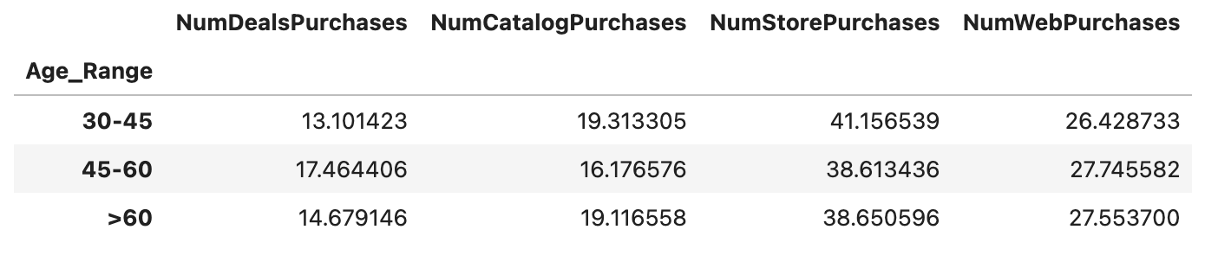

- Customers with kids prefer online shopping: Supported; households with children show higher web purchases. If you look into the data, the customer with no children has 26%, while the customer with 1 or more has a high percentage of around 35% or more.
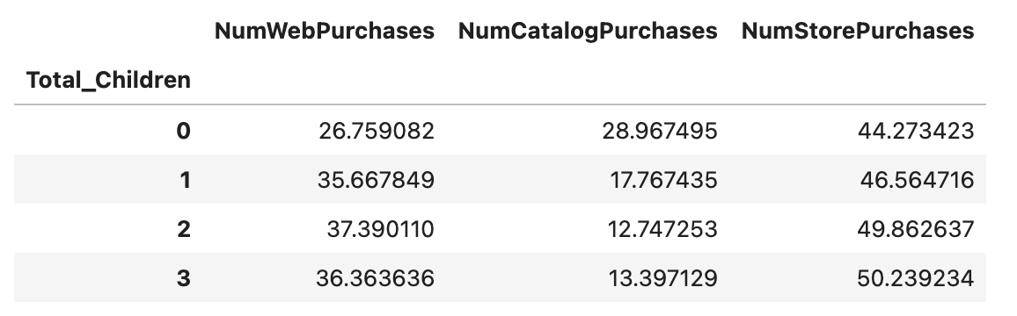
- Cannibalization of store sales by other channels: We have seen customer are more preferred to buy via store compared to other modes, also we see a positive correlation between store and web purchases.
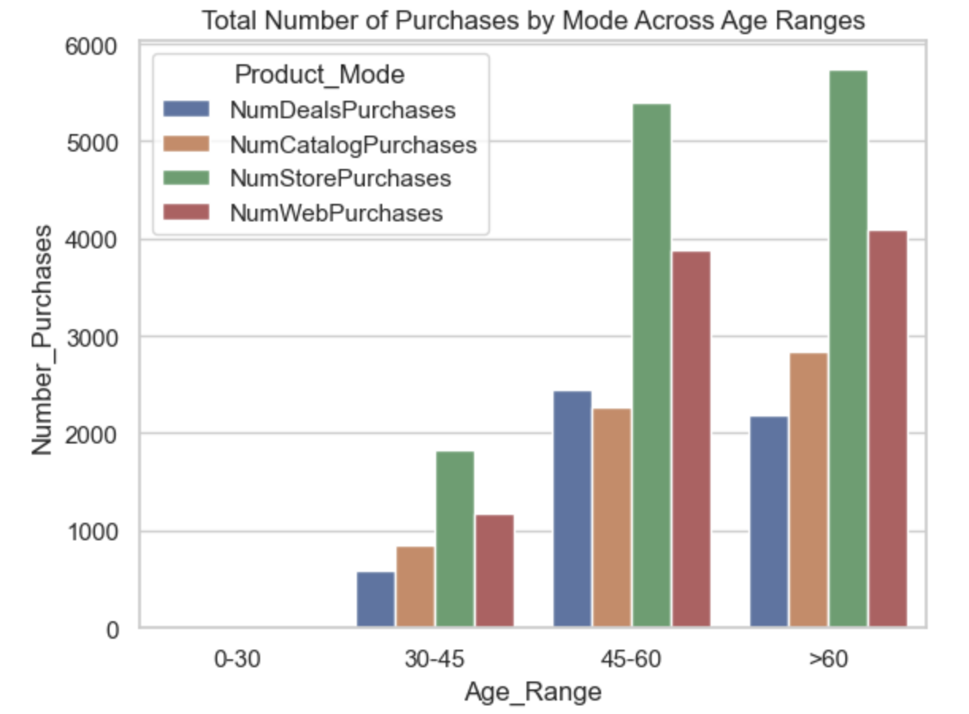
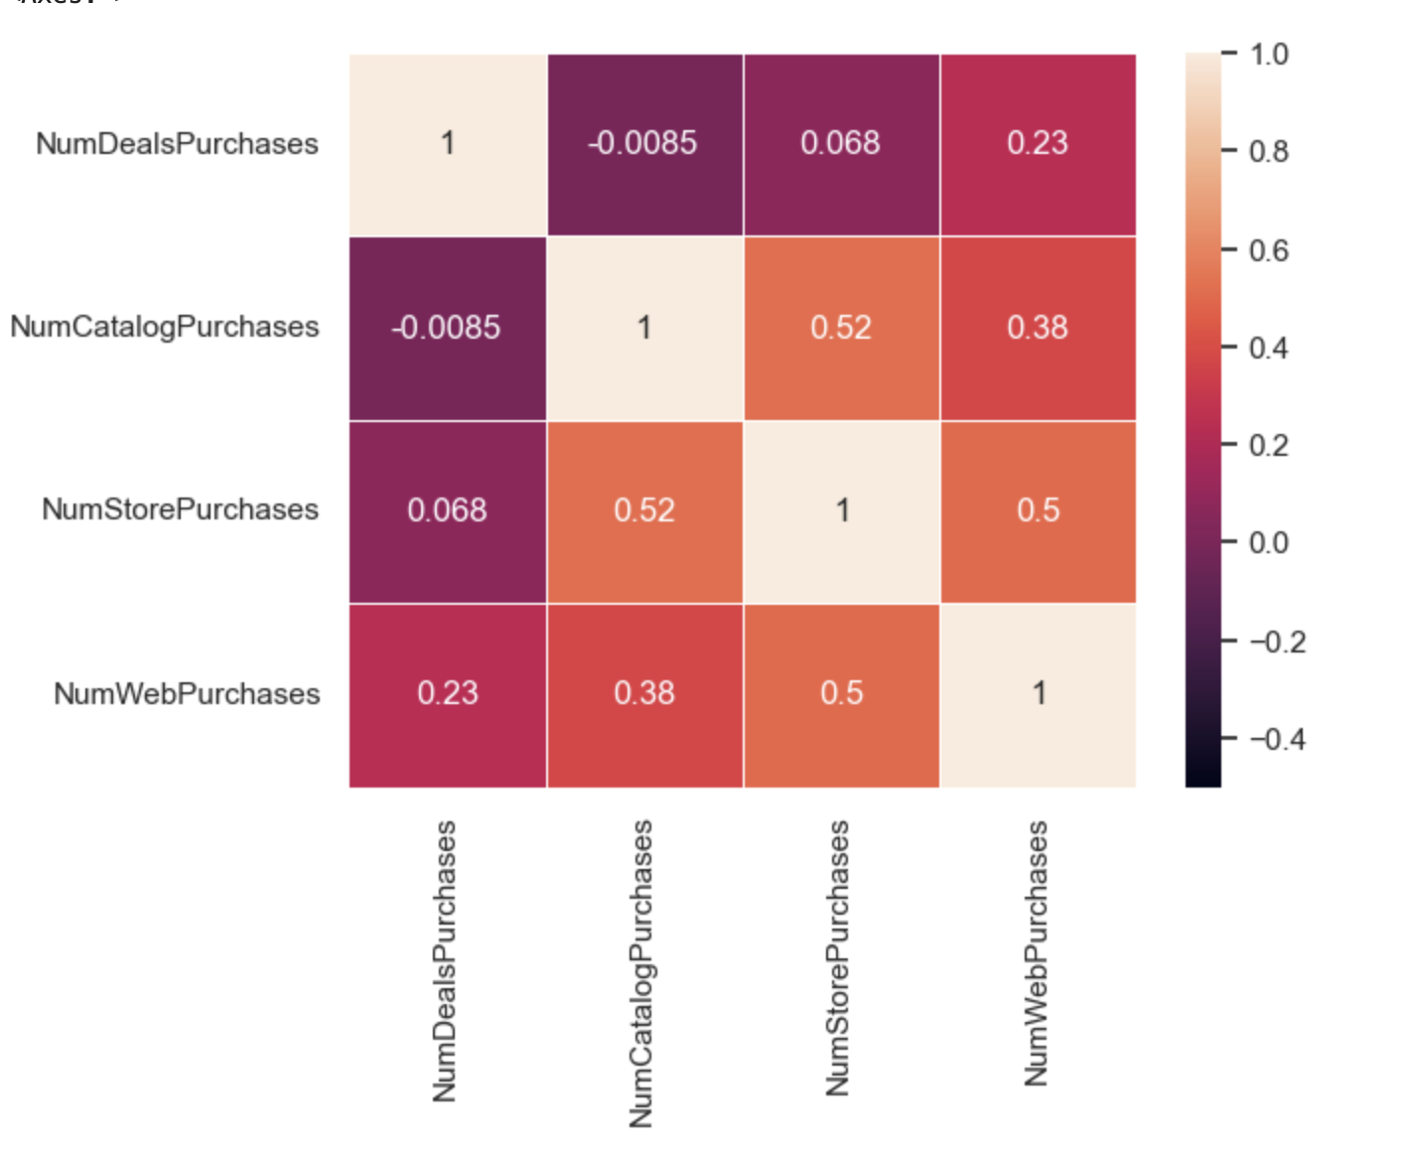

- US vs Rest of World: US customers show significantly lower purchases compared to other countries.
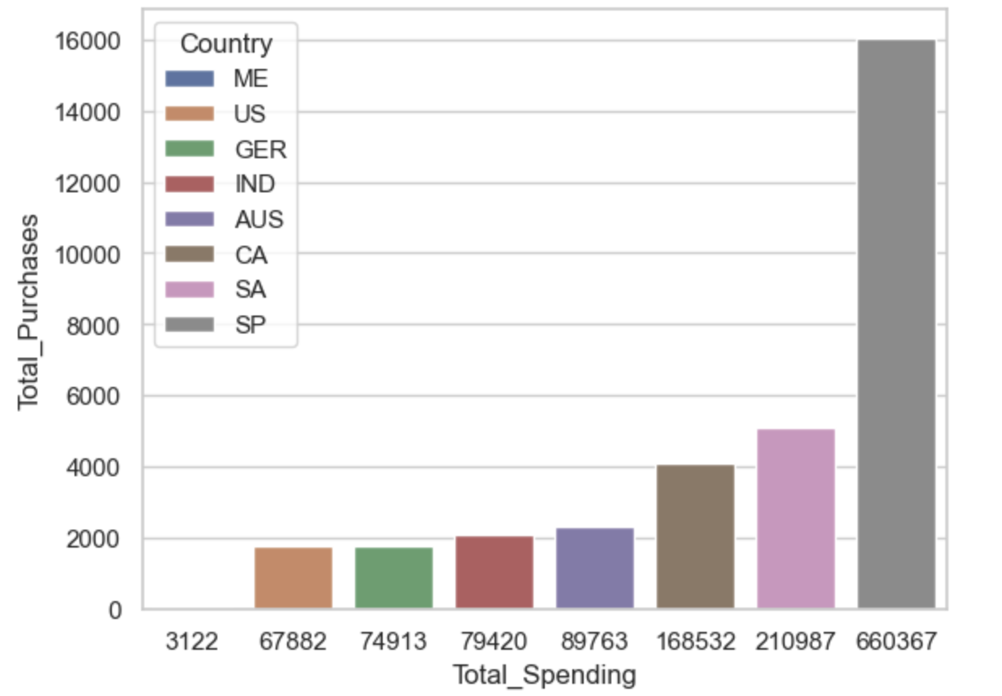

Which products are performing the best, and which are performing the least in terms of revenue?

Is there any pattern between the age of customers and the last campaign acceptance rate?

Which Country has the greatest number of customers who accepted the last campaign?

Do you see any pattern in the no. of children at home and total spend?

Education background of the customers who complained in the last 2 years.

Insights from Visualizations
- Product Performance: Wines generate the highest revenue; gold products the least.
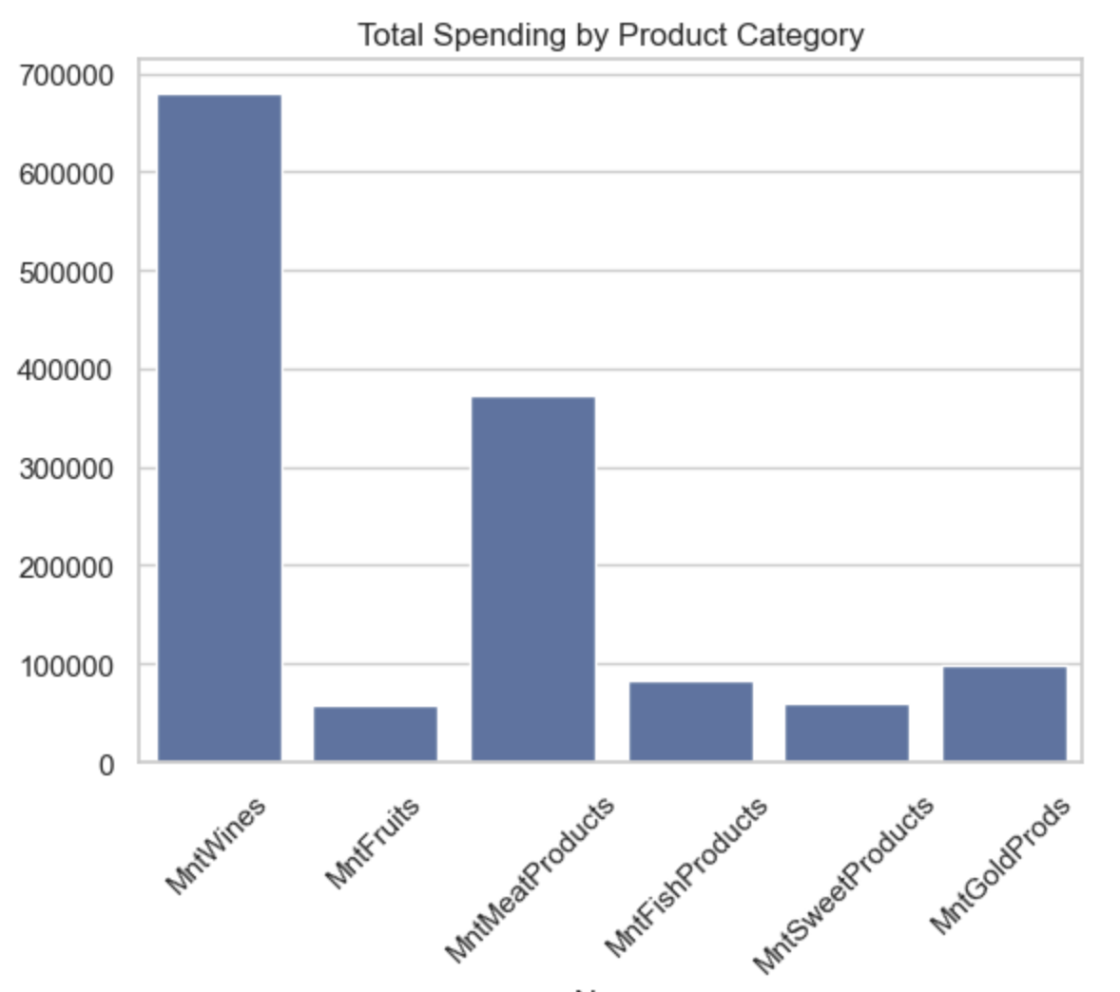
- Age vs Campaign Acceptance: Younger customers are more likely to accept campaigns; acceptance declines with age.
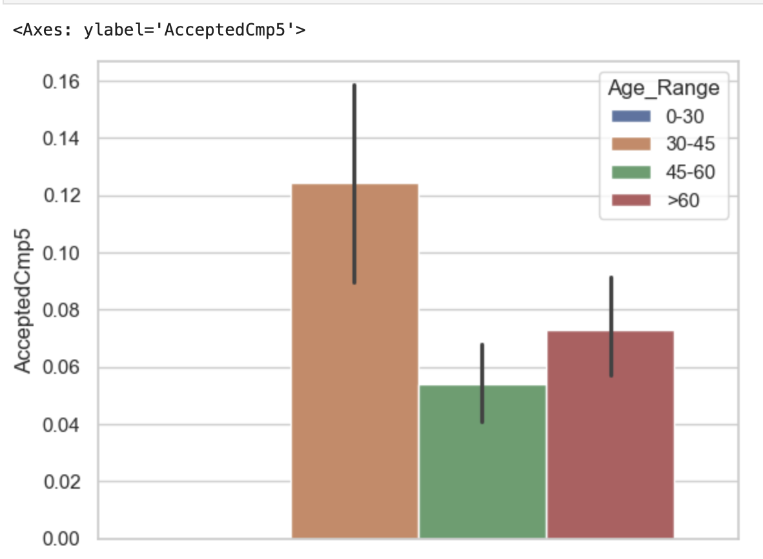
- Country with Highest Acceptance: SP has the highest campaign acceptance.
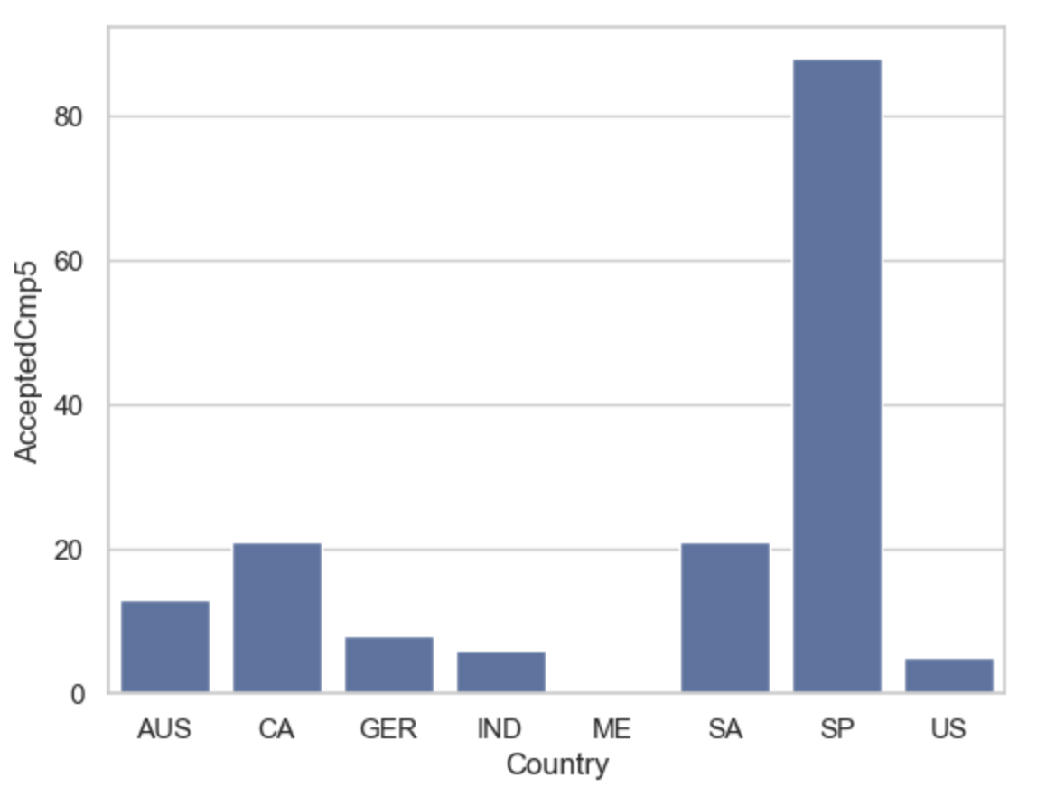
- Children vs Spending: Families with more children spend less overall, particularly on luxury items.
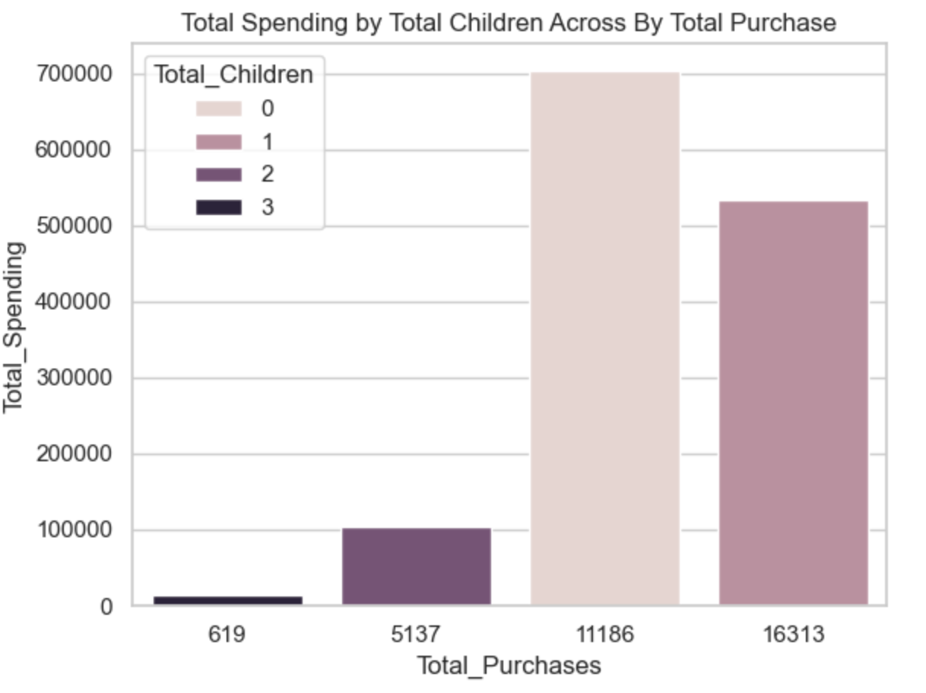
- Complaints by Education: Complaints concentrated among customers with basic education backgrounds.
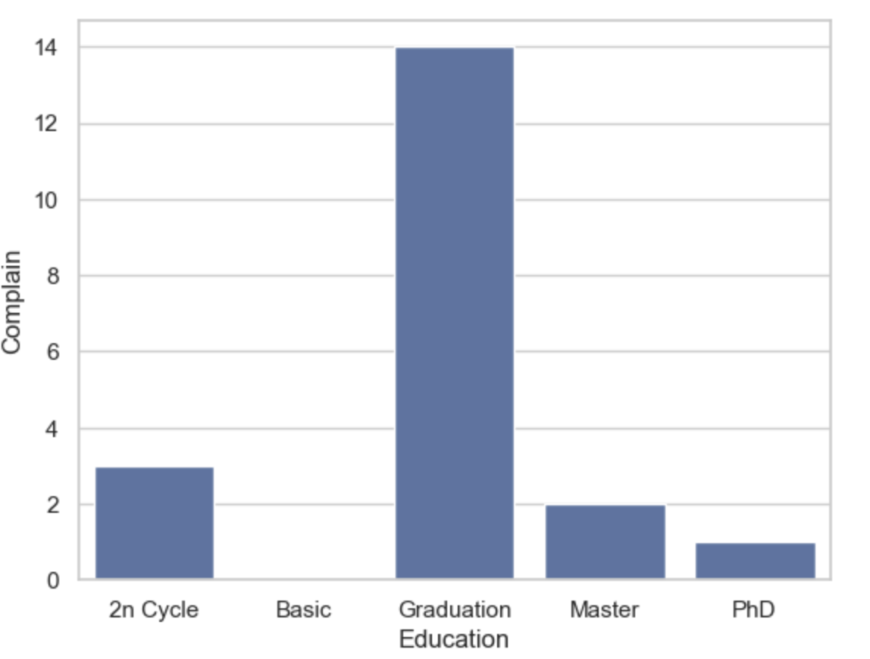

Conclusion
- Targeting Strategy: Focus online campaigns on younger, child-bearing households; emphasise in-store promotions for older demographics.
- Product Strategy: Increase marketing for underperforming categories like fruits, gold and sweets.
- Customer Service: Address dissatisfaction among less-educated segments to reduce complaints.

